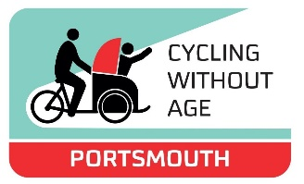 Cycling Without Age Self-Referral Form

Applicant Name:
Address:
Date of Birth:
Contact Number:
Email Address:
Emergency Name and Contact Details:

Name of Carer: (if attending)
Carer Contact Details: (if attending)
Date of Application:
GP Practice Name and Address:

Reason for Self-Referral:

Support Needs
Does the applicant use a walking stick? | Yes/No
Does the applicant use a frame? | Yes/No
Does the applicant use a mobility scooter? | Yes/No
Can the applicant go up and down stairs without assistance? | Yes/No
Can the applicant get in and out of a taxi? | Yes/No
The total weight does not exceed;  120kg for one passenger  150kg for two passengers. | Yes/No
For applicants with mobility issues - does the applicant have a carer to assist them? | Yes/No
Additional Notes: Please include any appropriate health conditions.

Hobbies/Interests – this will help with linking a suitable volunteer to the client.

Availability – Are there any times/dates that the applicant is not available?

Preferred meeting point:
Old Portsmouth Square Tower
Southsea Medical Centre
Pyramids Centre
Bransbury Park
Hayling Ferry (Eastney)

Cycling without Age Portsmouth staff provide 1:1 support,
Is lone visiting appropriate if no carer present?
Confirmation that patient is not acutely ill at the point of referral
Confirmation that the patient agrees to this referral and understands the information on this form will be shared with The YOU Trust – and this has been recorded in patient notes

Using any number from 0 to 10, where 0 is worst, and 10 is best, how would you rate your current health and wellbeing?

10 | 9 | 8 | 7 | 6 | 5 | 4 | 3 | 2 | 1 | 0

Please email to:
Cyclingwithoutage@theyoutrust.org.uk
and we will be in contact.

